Theme: Movies

Deliverables:
- ER Diagram
- Relational Schema
- DDL Queries
- DML Queries

ER Diagram:
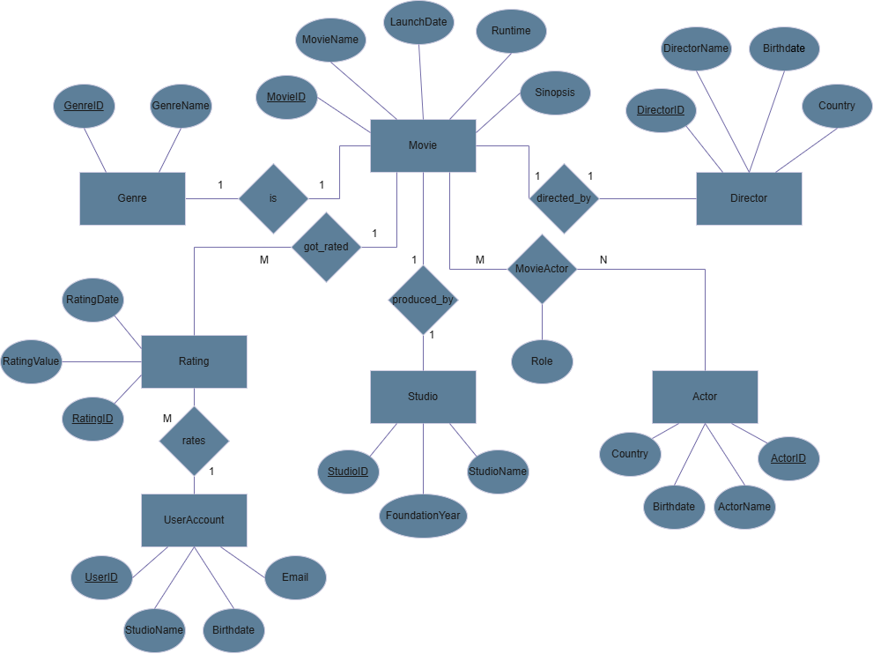

Relational Schema:
Foreign Key = Red
Note: MovieActor attributes MovieID and ActorID are also primary keys
- Movie(MovieID, MovieName, LaunchDate, Runtime, GenreID, StudioID, DirectorID, Synopsis)
- Studio(StudioID, StudioName, FoundationYear)
-Director(DirectorID,DirectorName,Birthdate,Country)
- Genre(GenreID, GenreName)
- Actor(ActorID, ActorName, Birthdate, Country)
- MovieActor(MovieID, ActorID, RoleName)
- Rating(RatingID, MovieID, RatingValue, UserID, RatingDate)
- UserAccount (UserID, Username, Email, Birthdate)
DDL:
Below you will see the DDL queries and photos of the DDL queries being executed.

-- 1. Genre
CREATE TABLE Genre (
GenreID INT PRIMARY KEY AUTO_INCREMENT,
GenreName VARCHAR(100) NOT NULL UNIQUE
);
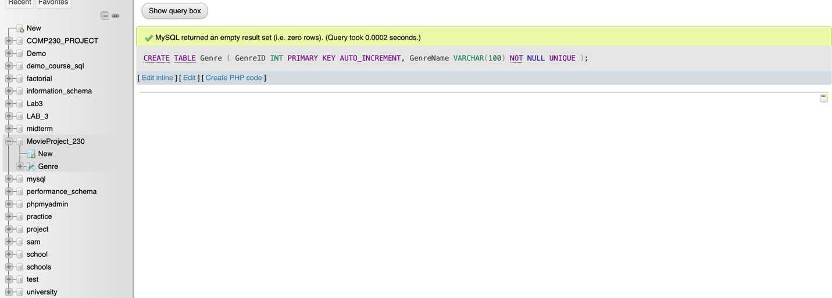

-- 2. Studio
CREATE TABLE Studio (
StudioID INT PRIMARY KEY AUTO_INCREMENT,
StudioName VARCHAR(150) NOT NULL UNIQUE,
FoundationYear INT
);
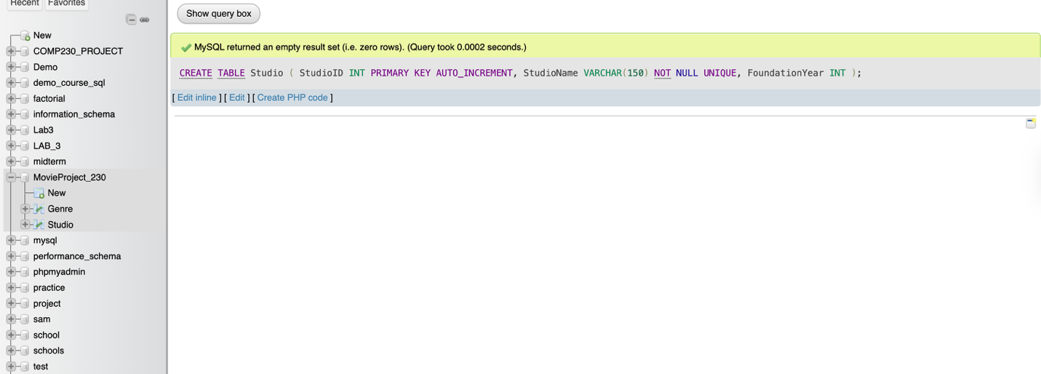

-- 3. Director
CREATE TABLE Director (
DirectorID INT PRIMARY KEY AUTO_INCREMENT,
DirectorName VARCHAR(150) NOT NULL,
Birthdate DATE
);
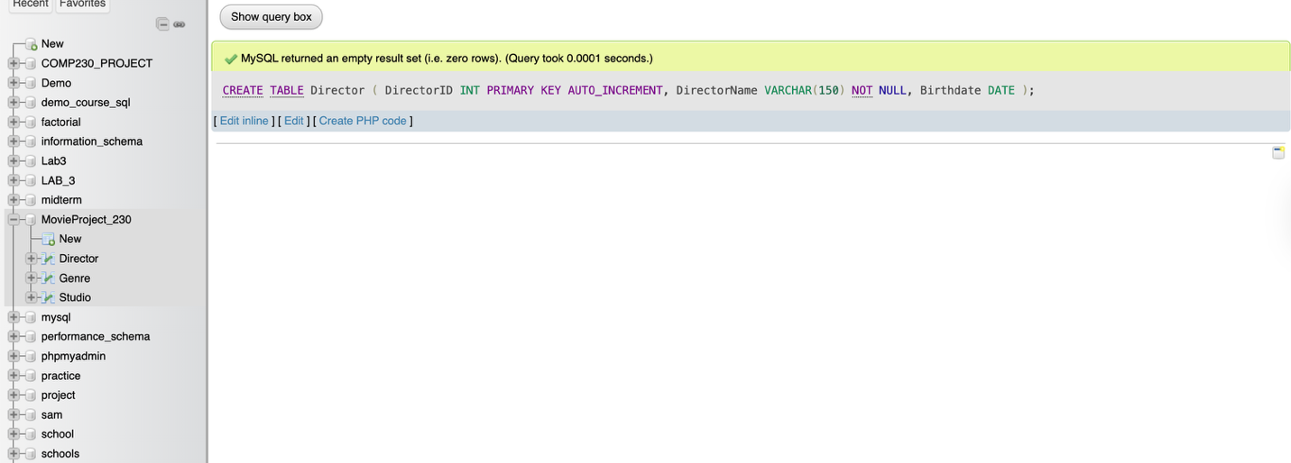

-- 4. Movie
CREATE TABLE Movie (
MovieID INT PRIMARY KEY AUTO_INCREMENT,
Title VARCHAR(200) NOT NULL,
LaunchDate DATE,
GenreID INT,
StudioID INT,
DirectorID INT,
Runtime INT,
Synopsis TEXT,

FOREIGN KEY (GenreID) REFERENCES Genre(GenreID),
FOREIGN KEY (StudioID) REFERENCES Studio(StudioID),
FOREIGN KEY (DirectorID) REFERENCES Director(DirectorID)
);
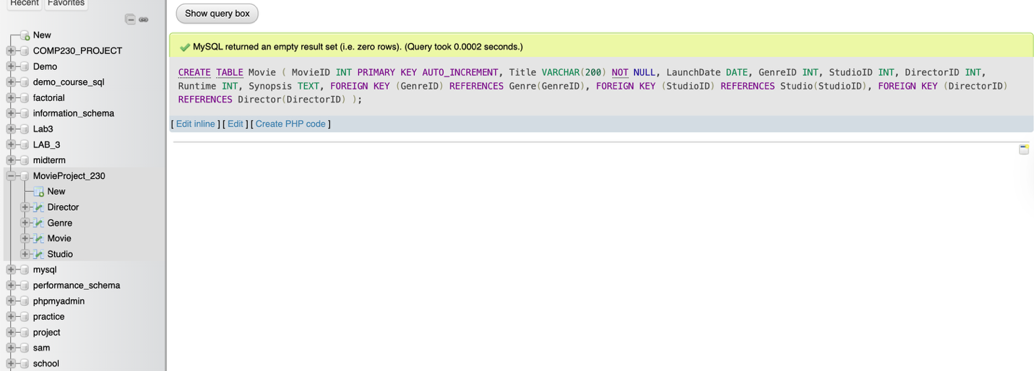

-- 5. Actor
CREATE TABLE Actor (
ActorID INT PRIMARY KEY AUTO_INCREMENT,
ActorName VARCHAR(150) NOT NULL,
Birthdate DATE
);
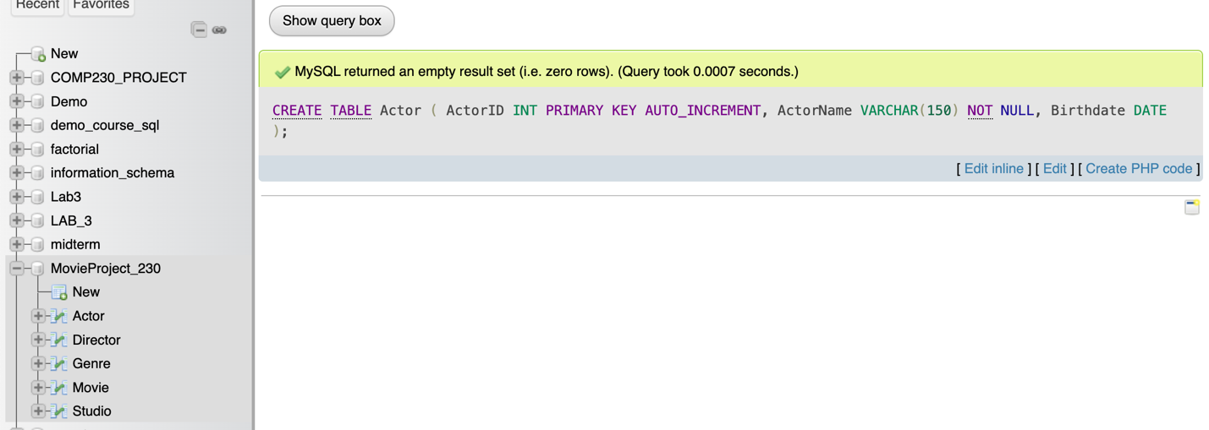

-- 6. Movie <-> Actor (M:N)
CREATE TABLE MovieActor (
MovieID INT,
ActorID INT,
RoleName VARCHAR(150),

PRIMARY KEY (MovieID, ActorID),
FOREIGN KEY (MovieID) REFERENCES Movie(MovieID) ON DELETE CASCADE,
FOREIGN KEY (ActorID) REFERENCES Actor(ActorID) ON DELETE CASCADE
);
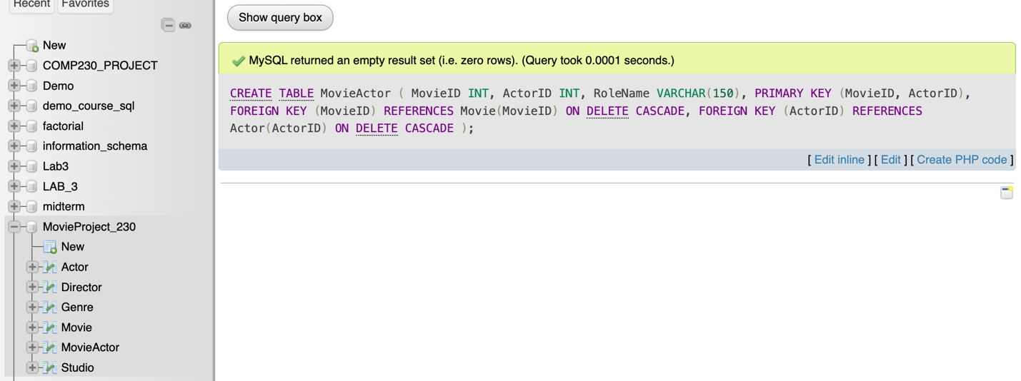

-- 7. UserAccount
CREATE TABLE UserAccount (
UserID INT PRIMARY KEY AUTO_INCREMENT,
Username VARCHAR(100) NOT NULL UNIQUE,
Email VARCHAR(200) NOT NULL UNIQUE,
Birthdate DATE
);
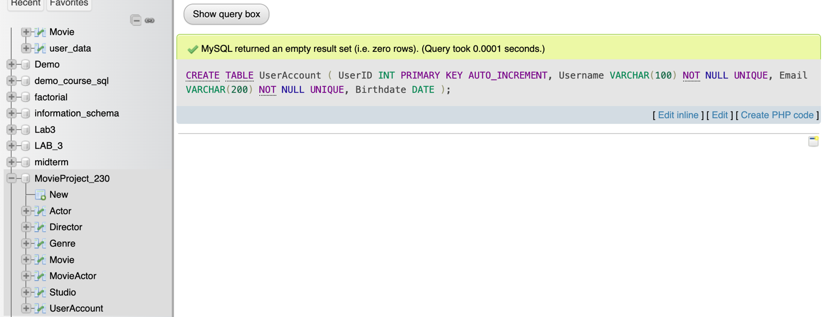

-- 8. Rating
CREATE TABLE Rating (
RatingID INT PRIMARY KEY AUTO_INCREMENT,
MovieID INT NOT NULL,
UserID INT NOT NULL,
RatingValue DECIMAL(3,1) CHECK (RatingValue >= 0 AND RatingValue <= 10),
RatingDate DATE DEFAULT CURRENT_DATE,

FOREIGN KEY (MovieID) REFERENCES Movie(MovieID) ON DELETE CASCADE,
FOREIGN KEY (UserID) REFERENCES UserAccount(UserID) ON DELETE CASCADE
);
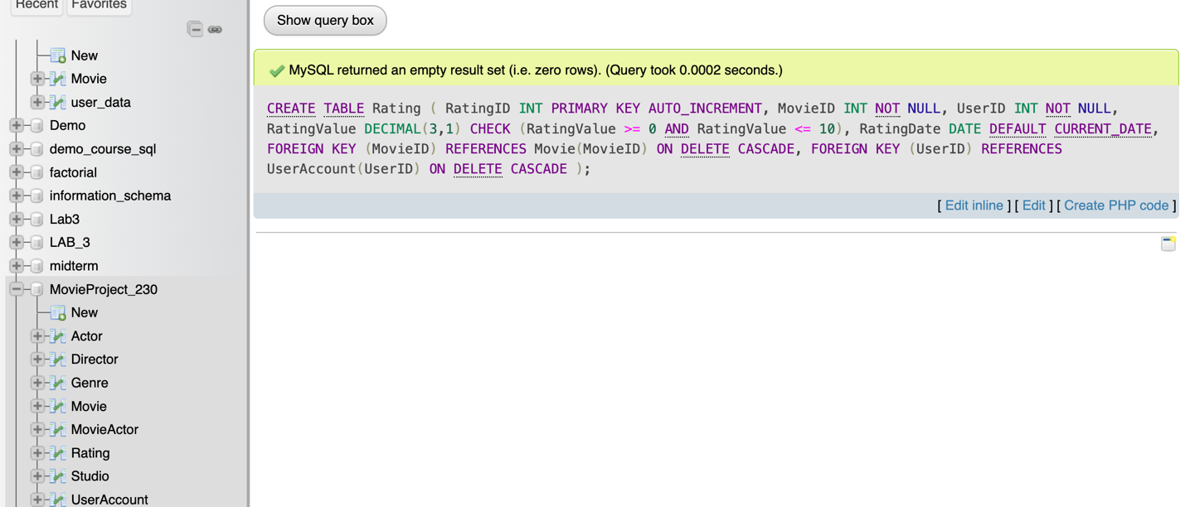

DML
DML - Insert data in the table
-- 1. Adding Genres
INSERT INTO Genre (GenreName) VALUES
('Action'),
('Comedy'),
('Drama'),
('Horror'),
('Science Fiction');
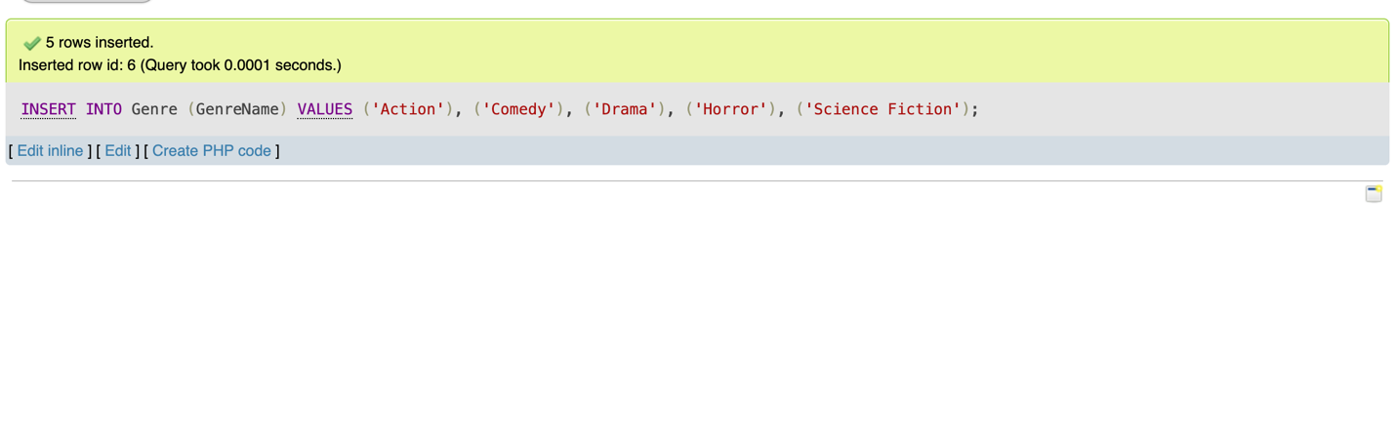
-- 2. Inserting Studios
INSERT INTO Studio (StudioName, FoundationYear) VALUES
('Universal Pictures', 1912),
('Warner Bros.', 1923),
('Paramount Pictures', 1912),
('20th Century Studios', 1935);
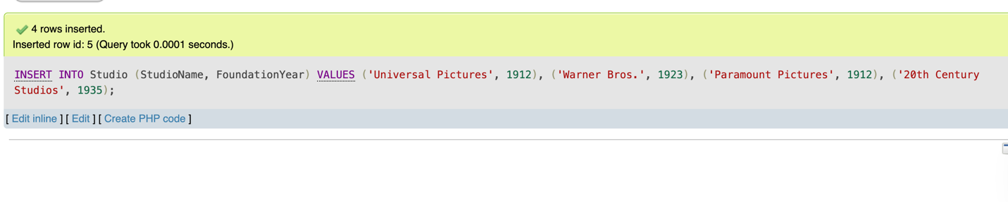
-- 3. Insert Directors
INSERT INTO Director (DirectorName, Birthdate) VALUES
('Steven Spielberg', '1946-12-18'),
('Christopher Nolan', '1970-07-30'),
('Quentin Tarantino', '1963-03-27'),
('Greta Gerwig', '1983-08-04');
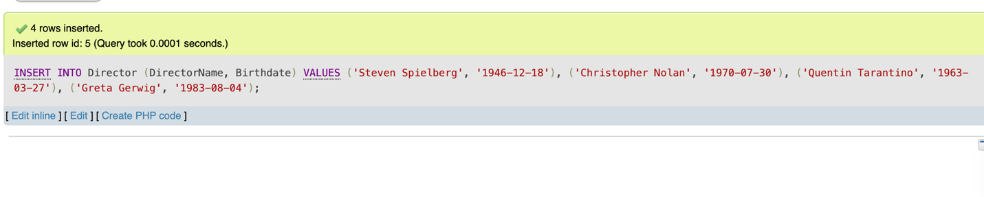
-- 4. Insert Movie
INSERT INTO Movie (Title, LaunchDate, GenreID, StudioID, DirectorID, Runtime, Synopsis) VALUES
('Jurassic Park', '1993-06-11', 1, 1, 1, 127, 'A theme park suffers a major security breakdown.'),
('Inception', '2010-07-16', 1, 2, 2, 148, 'A thief enters dreams to steal secrets.'),
('Pulp Fiction', '1994-10-14', 3, 3, 3, 154, 'Interwoven stories of crime and redemption.'),
('Little Women', '2019-12-25', 3, 2, 4, 135, 'A period drama about four sisters growing up in Massachusetts.'),
('The Wall', '2025-12-01', 1, 1, 1, 7, 'A movie about a wall.'),
('A long Walk to Water', '2025-12-02', 3, 2, 2, 2, 'A movie about a boy and an elephant.');
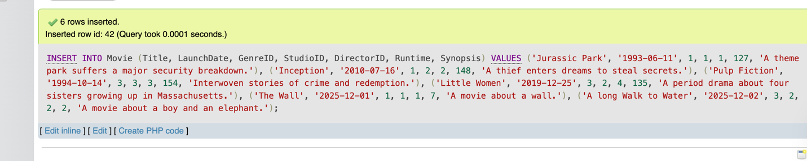

-- 5. Insert Actors
INSERT INTO Actor (ActorName, Birthdate) VALUES
('Leonardo DiCaprio', '1974-11-11'),
('Samuel L. Jackson', '1948-12-21'),
('Emma Watson', '1990-04-15'),
('Timothée Chalamet', '1995-12-27');
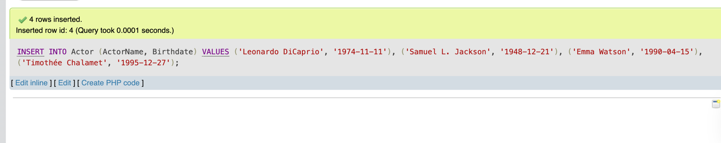

-- 6. Insert MovieActor
INSERT INTO MovieActor (MovieID, ActorID, RoleName) VALUES
(1, 1, 'Dr. Alan Grant'), -- Jurassic Park
(2, 1, 'Dom Cobb'), -- Inception
(3, 2, 'Jules Winnfield'), -- Pulp Fiction
(4, 3, 'Jo March'), -- Little Women
(4, 4, 'Laurie Laurence'); -- Little Women
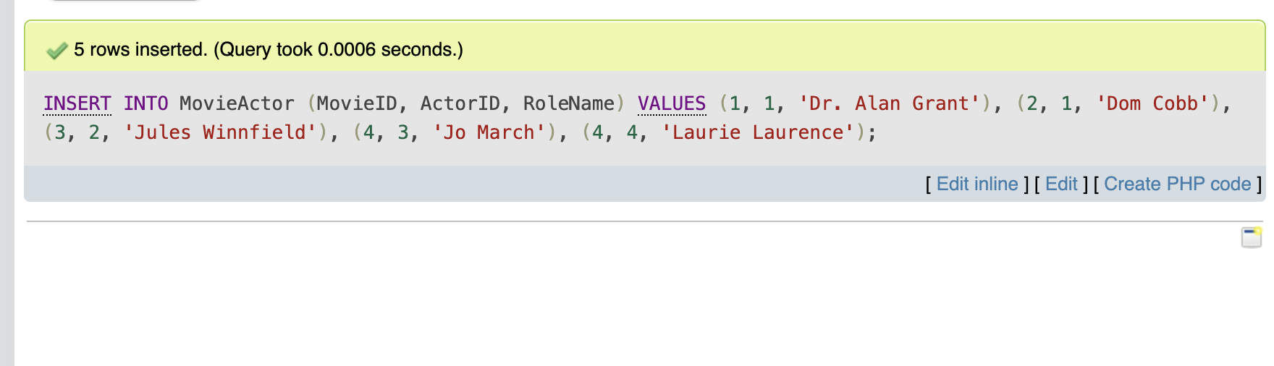

-- 7. Insert UserAccount
INSERT INTO UserAccount (Username, Email, Birthdate) VALUES
('moviebuff123', 'buff123@example.com', '1995-05-15'),
('cinemalover', 'lover@example.com', '1988-09-22'),
('hollywoodfan', 'fan@example.com', '2000-01-30');
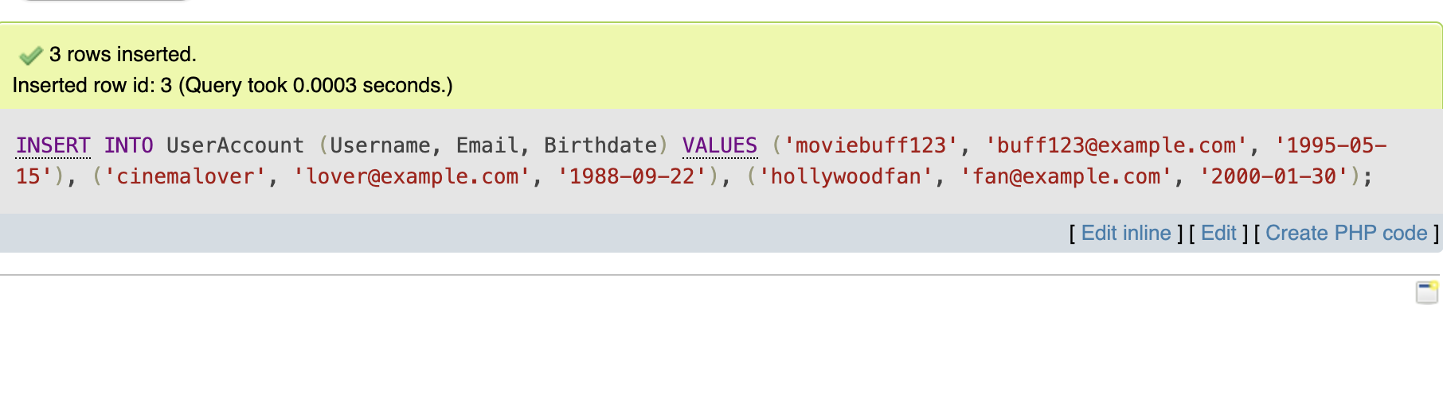
-- 8. Insert Rating
INSERT INTO Rating (MovieID, UserID, RatingValue, RatingDate) VALUES
(1, 1, 9.5, '2025-12-01'),
(2, 1, 8.7, '2025-12-02'),
(3, 2, 9.0, '2025-12-01'),
(4, 3, 7.8, '2025-12-02');
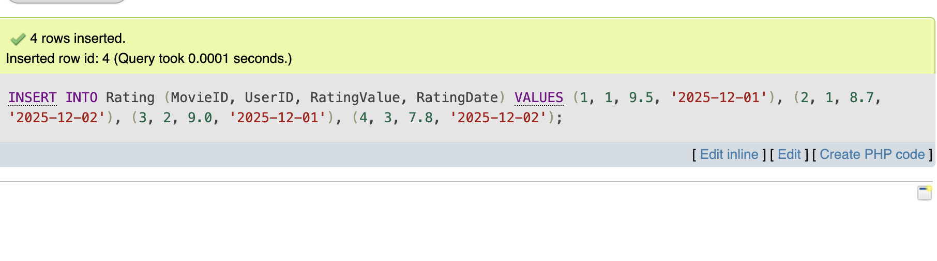
DML - Update examples
-- 9. Update a director’s birthdate
UPDATE Director
SET Birthdate = '1970-07-20'
WHERE DirectorName = 'Christopher Nolan';
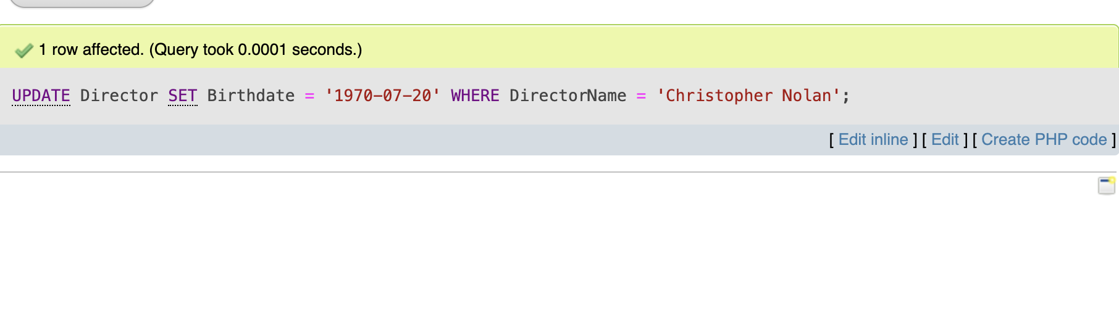
-- 10. Correct a movie runtime
UPDATE Movie
SET Runtime = 150
WHERE Title = 'Inception';
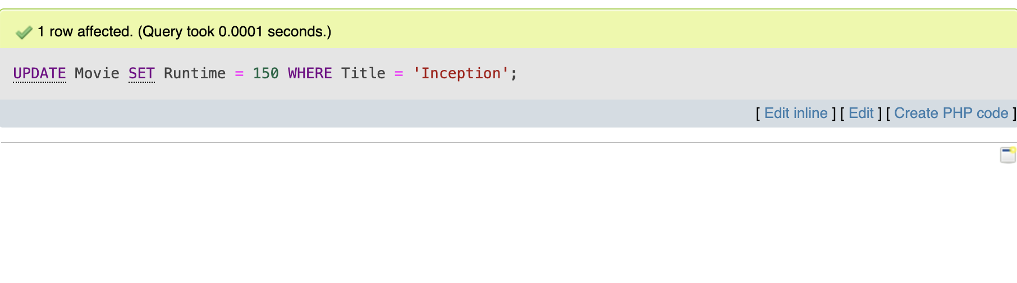

-- 11. Update a user's email
UPDATE UserAccount
SET Email = 'newbuff123@example.com'
WHERE Username = 'moviebuff123';
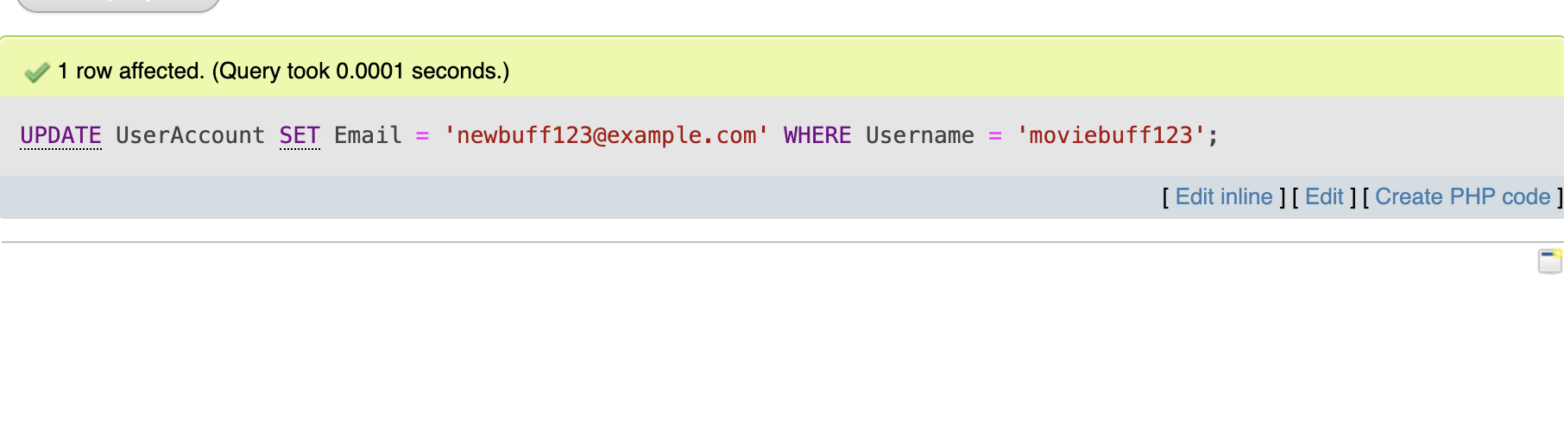
DML - Delete:
-- 12. Delete an Actor from the database
DELETE FROM Actor
WHERE ActorName = 'Timothée Chalamet';
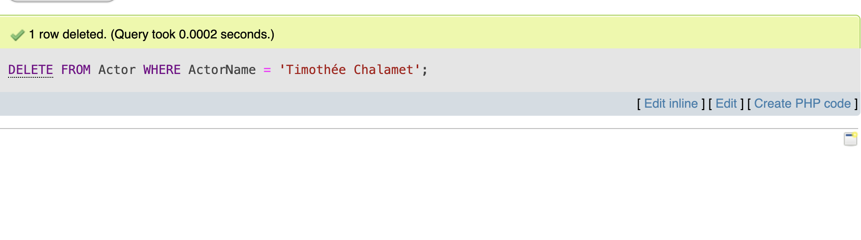
-- 13. Delete a movie rating
DELETE FROM Rating
WHERE RatingID = 2;
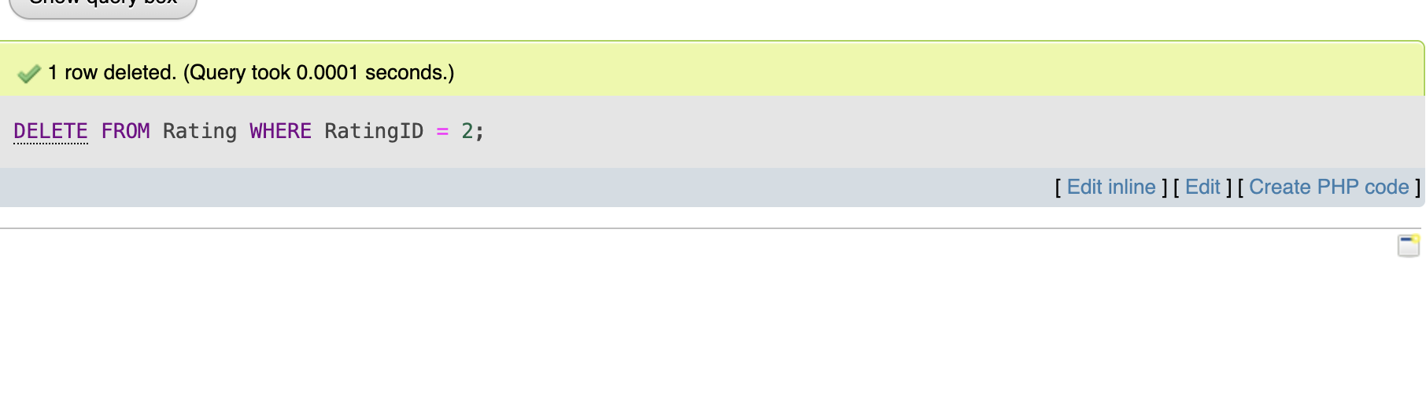
-- 14. Delete a genre
DELETE FROM Genre
WHERE GenreName = 'Horror';
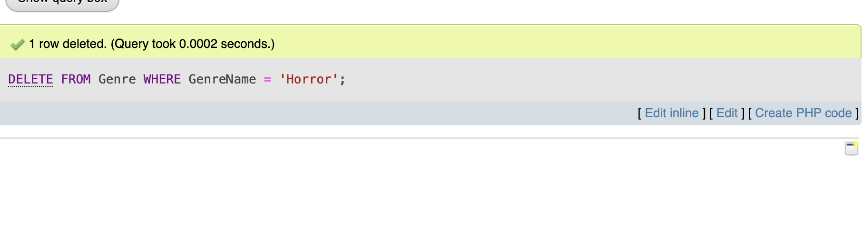
DML - Select and Filter elements
-- 15. List all movies with the director and genre
SELECT Movie.Title, Director.DirectorName, Genre.GenreName, Movie.Runtime
FROM Movie
JOIN Director ON Movie.DirectorID = Director.DirectorID
JOIN Genre ON Movie.GenreID = Genre.GenreID;
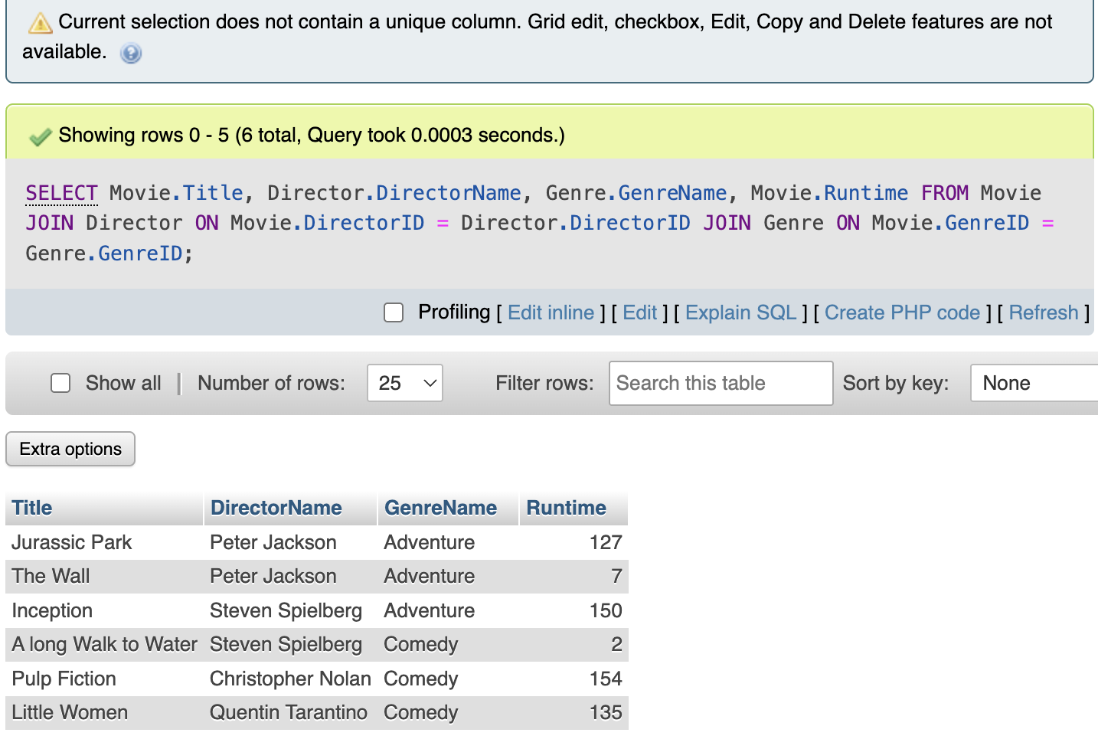

-- 16. Show top-rated movies
SELECT Movie.Title, AVG(Rating.RatingValue) AS AvgRating
FROM Movie
JOIN Rating ON Movie.MovieID = Rating.MovieID
GROUP BY Movie.MovieID
ORDER BY AvgRating DESC;
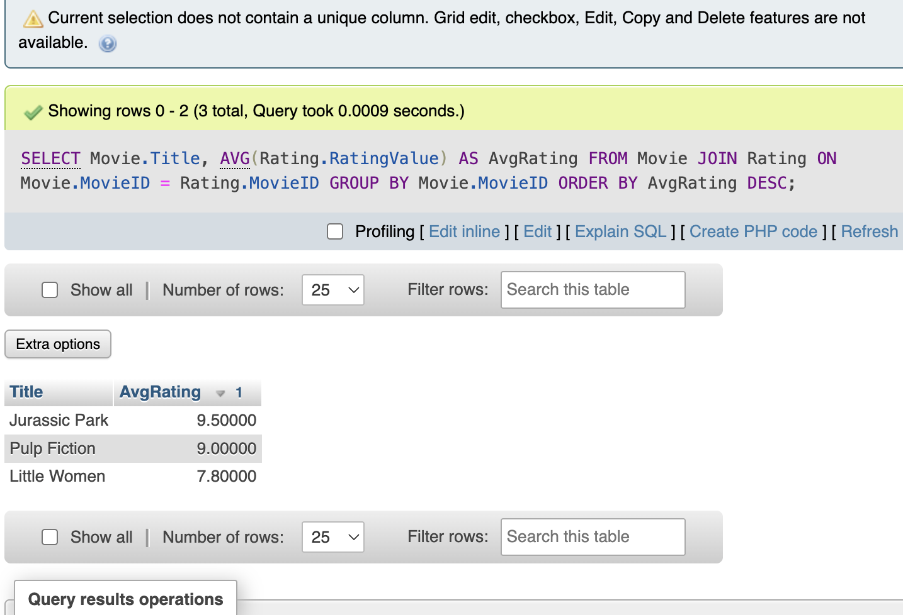

-- 17. Find all actors in a specific movie
SELECT Actor.ActorName, MovieActor.RoleName
FROM Actor
JOIN MovieActor ON Actor.ActorID = MovieActor.ActorID
JOIN Movie ON MovieActor.MovieID = Movie.MovieID
WHERE Movie.Title = 'Little Women';
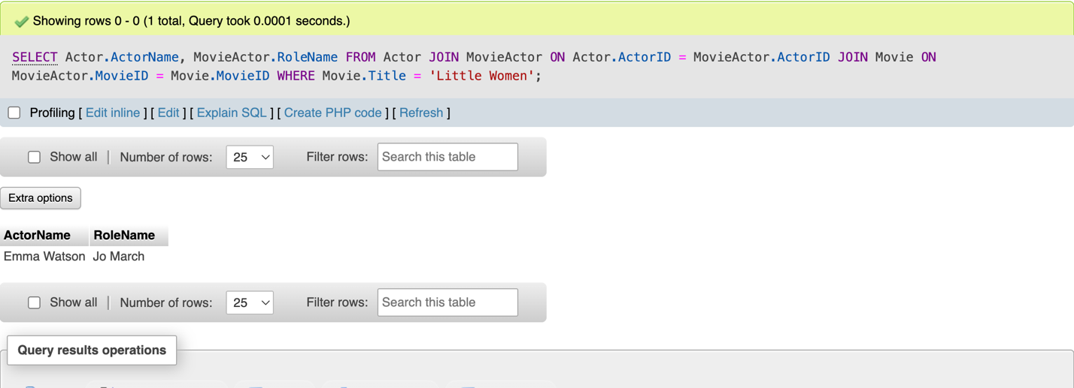

-- 18. List movies released after 2000 by a certain studio
SELECT Movie.Title, Studio.StudioName, Movie.LaunchDate
FROM Movie
JOIN Studio ON Movie.StudioID = Studio.StudioID
WHERE Movie.LaunchDate > '2000-01-01' AND Studio.StudioName = 'Warner Bros.';
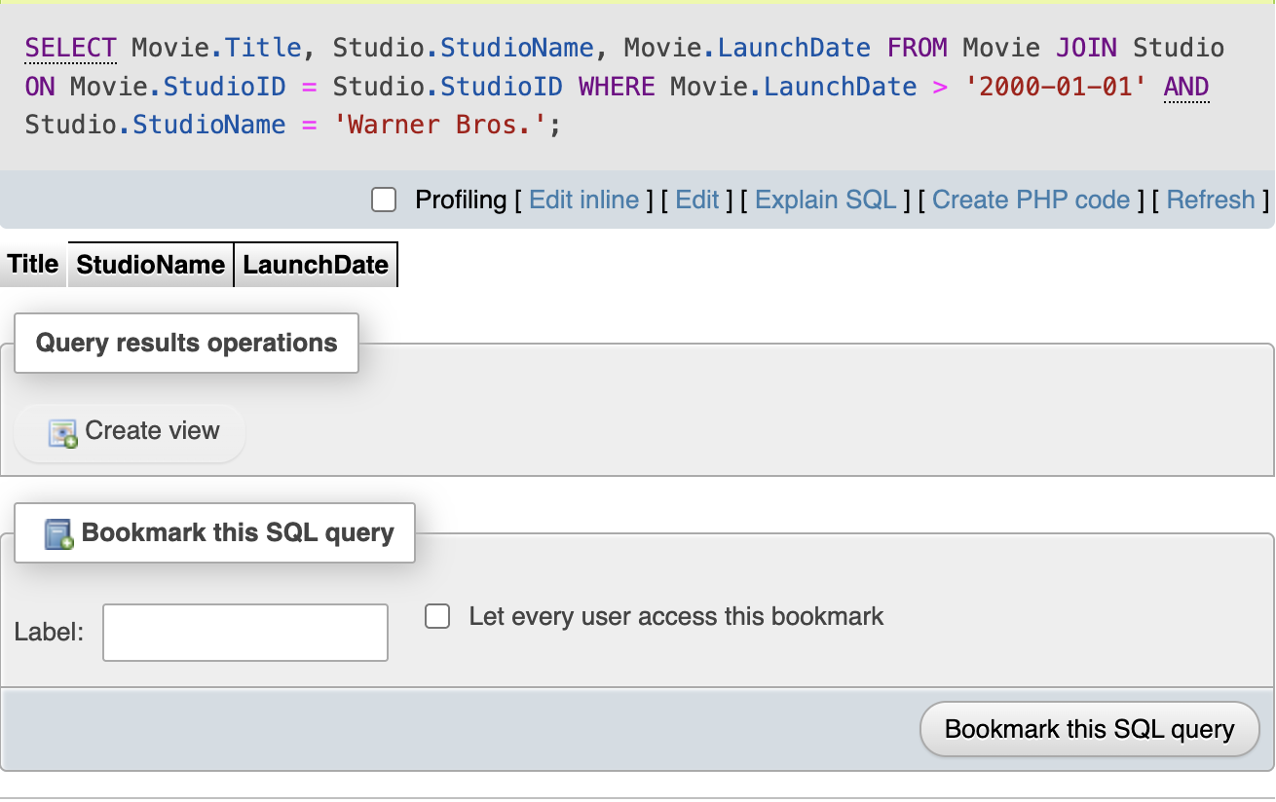

-- 19. Filter Movie by Genre
SELECT Movie.Title, Director.DirectorName, Genre.GenreName, Movie.Runtime
FROM Movie
LEFT JOIN Director ON Movie.DirectorID = Director.DirectorID
LEFT JOIN Genre ON Movie.GenreID = Genre.GenreID
WHERE Genre.GenreName = 'Action';
